Submitting your assignment:
Step1: Open your project in VS Code:

Step 2: Right-click the file you have been working on:
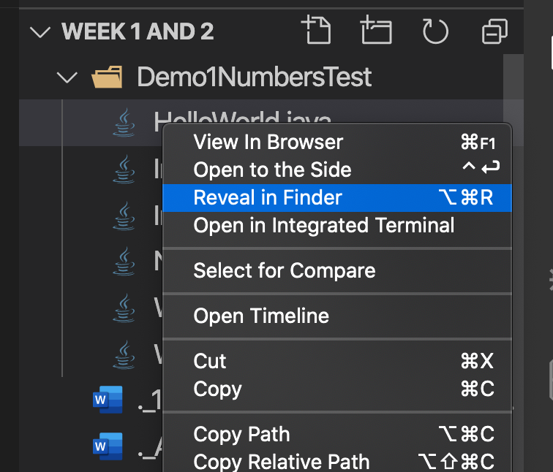
Step 3: In Mac, select “Reveal in Finder.”
For Windows Select “Reveal in File Explorer”

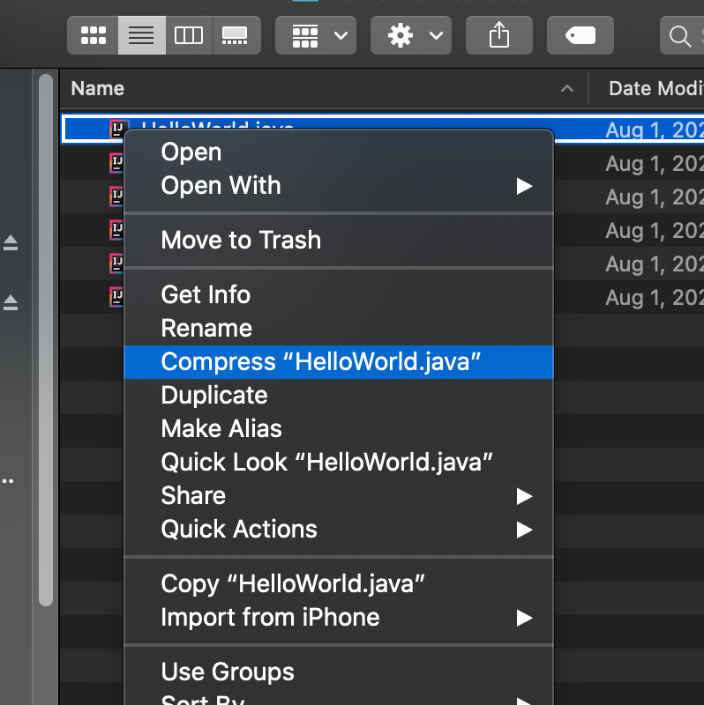

Step 4: in Mac Right Click the file and select “Compress.”

And In Windows Select “Send to” Compress”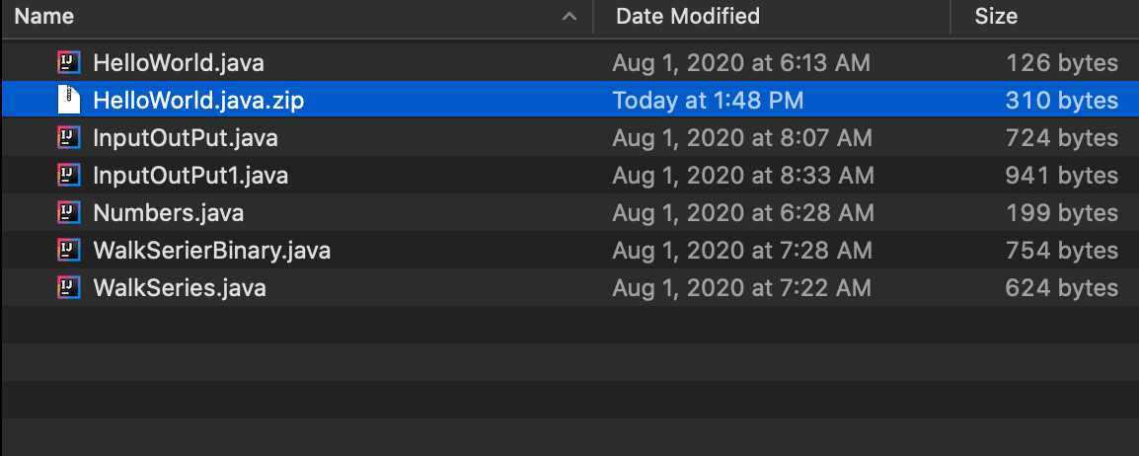

Step 5: Select the “Zipped File” and upload it to the assignment Bucket

